Depoyeement

Placing the application IIS

Go to RUN-

Type—inetmgr

It opens IIS panel

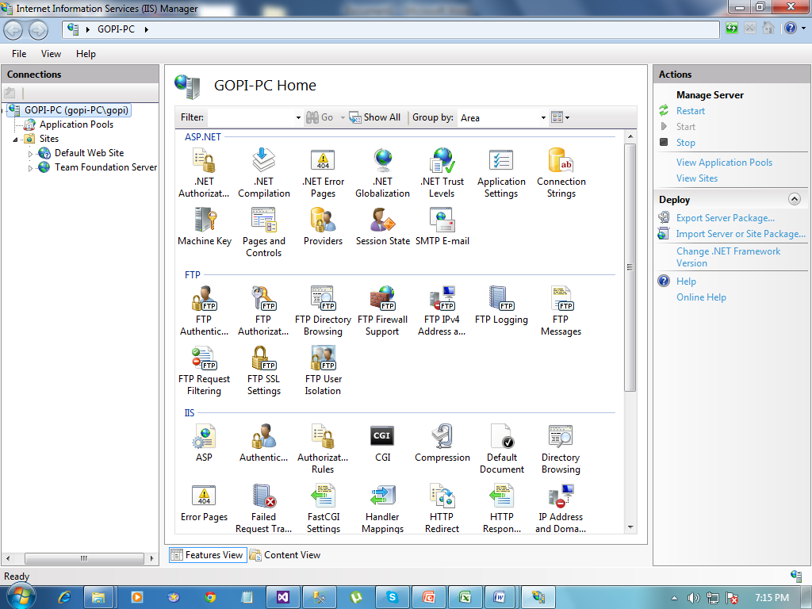

Rt click on the Default Web Site

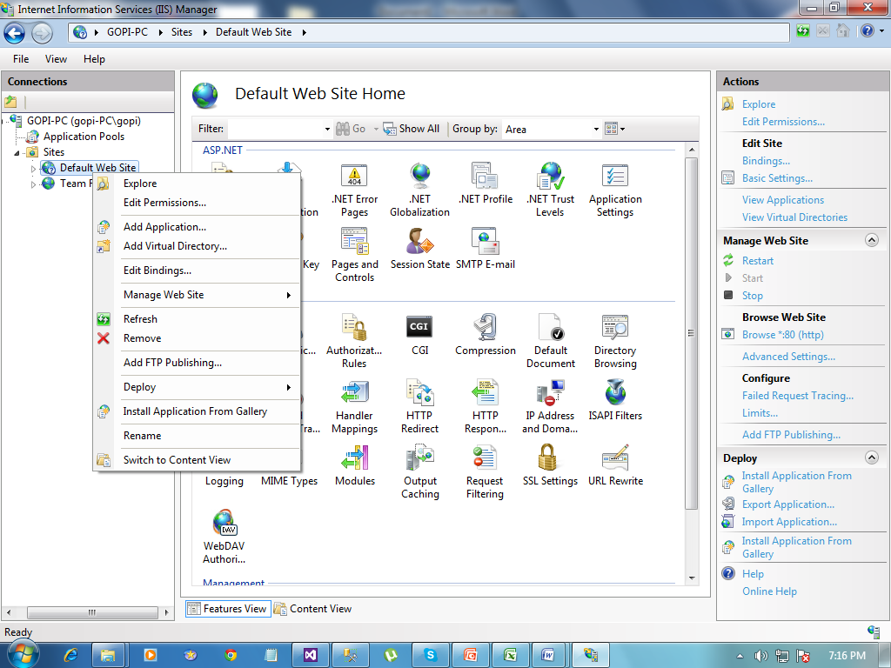

Select Add Virtual Directory

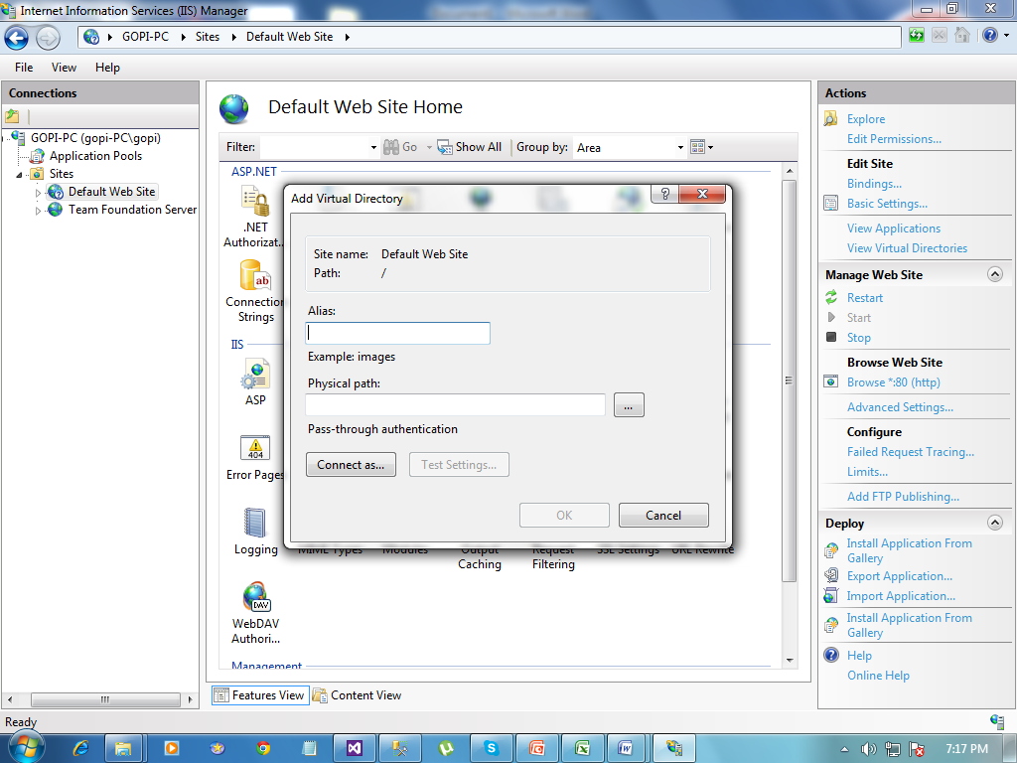

Give any alias name for your application

Select your application path

Then press OK

Your application stored in IIS

Go to Inernet Explorer or your Browser

Enter your IP with application name

Example : <http://192.100.68.100//Cyberspacemanagment>

It opens your application